# PRACTICA 2

(DEFUN CONTAR(A)

(IF (NULL A)

0

(IF (EQUAL (ATOM (CAR A)) T)

(IF (= (MOD (CAR A) 3) 0)

(+ 1 (CONTAR(CDR A))) (CONTAR(CDR A))

) (CONTAR(CDR A)))))

CONTAR

> (CONTAR A)

2

> SETQ B '(3 4 ( 5 6 )( 7 8 ) 9 10 11 12)

(3 4 (5 6) (7 8) 9 10 11 12)

> CONTAR B

3

> SETQ C '(3 4 ( 5 6 )( 7 8 ) 10 11 12)

(3 4 (5 6) (7 8) 10 11 12)

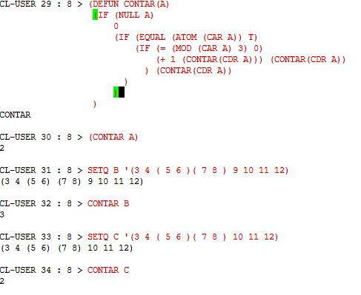> CONTAR C

2